This is the code to reproduce paper:

Network Intrusion Detection System with Stream Machine Learning in Fog Layer and Online Labeling in Cloud Layer - Shih-Hsien Chuang; Ren-Chieh Yang; Sheng-De Wang

Content:

* AXGB
* Baseline Model (ARF)
* Baseline Model (AXGB)
* Proposed Method

Result:

* Baseline Model (ARF)
  + Test then train part-3 data

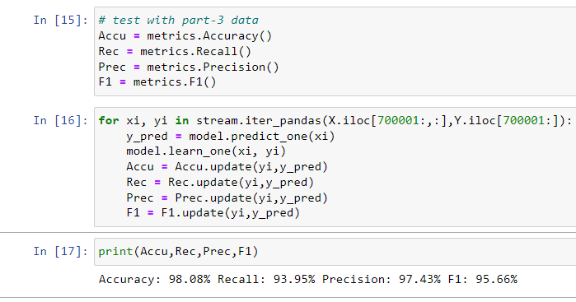

* + Only test (remove code model.learn_one(xi,yi) in block[16])

Accuracy: 77.51%, Recall=Precision=F1=0.00%

* Baseline Model (AXGB)

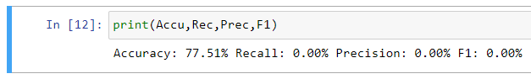

* Proposed Method

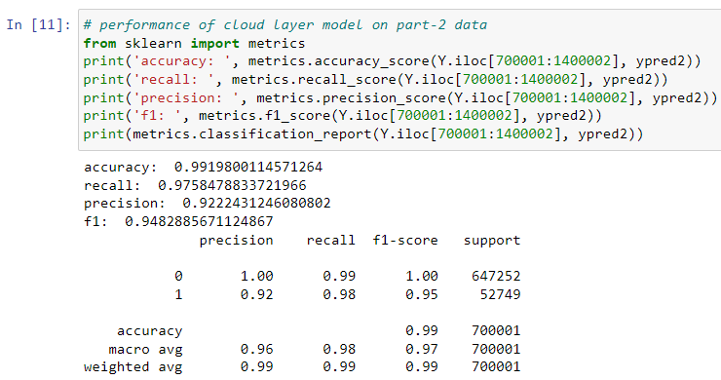

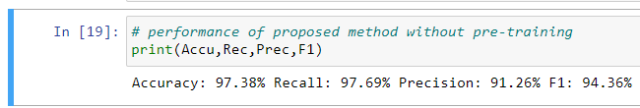

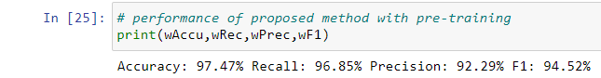

Dataset: UNSW-NB15

<https://research.unsw.edu.au/projects/unsw-nb15-dataset>

click “download from here” > csv files > UNSW-NB15_features, UNSW-NB15_1, UNSW-NB15_2, UNSW-NB15_3